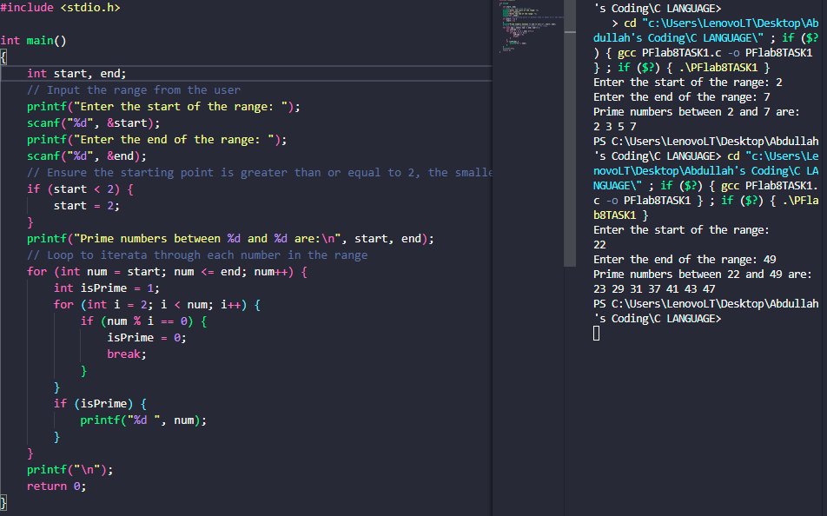

PF LAB 8 TASK 1: